**Full Stack Development with MERN**

**Project Documentation format**

**1. Introduction**

**Project Title:** **[online Learning platform using mern stack]**

**Team Members**: R.Harini sri

C.Chitra

P.Keerthi

P.Monisha

**2**. **Project Overview**

**Purpose:**

* An online learning platform is designed to provide educational content and resources through digital means, enabling learners to access courses, materials, and tools remotely. The primary goals of these platforms are to increase accessibility to education, offer flexible learning options, and provide personalized, self-paced learning experiences.
* They aim to support diverse learning styles, promote engagement, and help learners acquire new skills or knowledge in a wide range of subjects. These platforms often incorporate interactive features, such as quizzes, discussion forums, and multimedia content, to enhance the learning experience
* The purpose of an online learning platform is to provide accessible, flexible, and interactive education through digital tools and resources.
* Allows learners to study at their own pace, from anywhere, and on various devices. These platforms aim to make learning more convenient and inclusive, offering courses, materials, and support across a wide range of subjects and skills.

**Features:**

* **User Registration:** Sarah, a student interested in learning web development, visits the Online Learning Platform and creates an account. She provides her email and chooses a password.
* **Browsing Courses:** Upon logging in, Sarah is greeted with a user-friendly interface displaying various courses categorized by topic, difficulty level, and popularity.

She navigates through the course catalog, filtering courses by name and category until she finds a "Web Development Fundamentals" course that interests her.

* **Enrolling in a Course:** Sarah clicks on the course and reads the course description, instructor details, and syllabus. Impressed, she decides to enroll in the course.

After enrolling, Sarah can access the course materials, including video lectures, reading materials, and assignments.

* **Learning Progress:** Sarah starts the course and proceeds through the modules at her own pace. The platform remembers her progress, allowing her to pick up where she left off if she needs to take a break.
* **Interaction and Support:** Throughout the course, Sarah engages with interactive elements such as discussion forums and live webinars where she can ask questions and interact with the instructor and other learners.
* **Course Completion and Certification:** After completing all the modules and assignments, Sarah takes the final exam. Upon passing, she receives a digital certificate of completion, which she can download and add to her portfolio.
* **Paid Courses:** Sarah discovers an advanced web development course that requires payment. She purchases the course using the platform's payment system and gains access to premium content.
* **Teacher's Role:** Meanwhile, John, an experienced web developer, serves as a teacher on the platform. He creates and uploads new courses on advanced web development topics, adds sections to existing courses, and monitors course enrollments.
* **Admin Oversight:** The admin oversees the entire platform, monitoring user activity, managing course listings, and ensuring smooth operation. They keep track of enrolled students, handle any issues that arise, and maintain the integrity of the platform.

**3. Architecture**

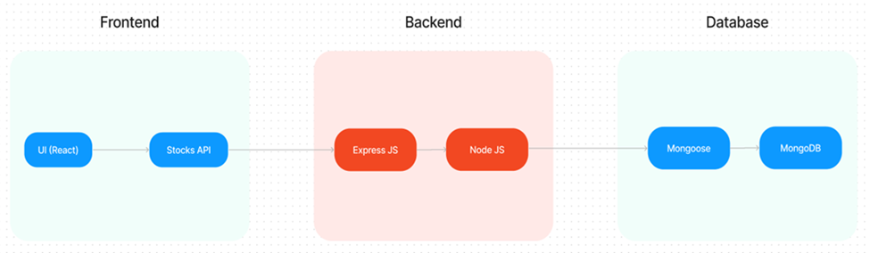

* The technical architecture of OLPapp follows a client-server model, where the frontend serves as the client and the backend acts as the server. The frontend encompasses not only the user interface and presentation but also incorporates the axios library to connect with backend easily by using RESTful Apis.

* The frontend utilizes the bootstrap and material UI library to establish real-time and better UI experience for any user.

* On the backend side, we employ Express.js frameworks to handle the server-side logic and communication.
* For data storage and retrieval, our backend relies on MongoDB. MongoDB allows for efficient and scalable storage of user data and necessary information about the place.

* Together, the frontend and backend components, along with Express.js, and MongoDB, form a comprehensive technical architecture for our OLPapp. This architecture enables real-time communication, efficient data exchange, and seamless integration, ensuring a smooth and immersive blogging experience for all users.

**E-R Diagram:**

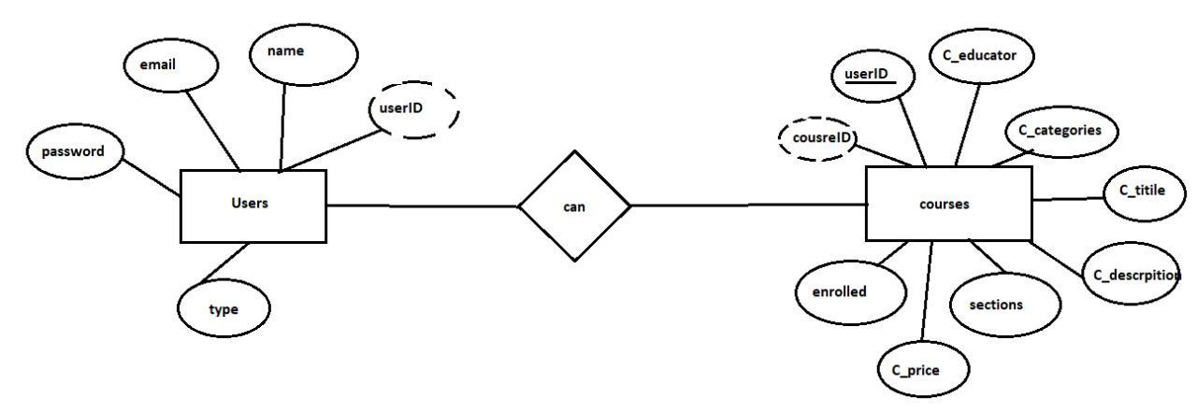

Here there is 2 collections namely users, courses which have their own fields in

**Users:**

1. _id: (MongoDB creates by unique default)
2. name
3. email
4. password
5. type

**Courses:**

1. userID: (can act as a foreign key )
2. _id: (MongoDB creates by unique default)
3. C_educator
4. C_categories
5. C_title
6. C_description
7. sections
8. C_price
9. Enrolled

**Frontend Development:**

* + **Installation of required tools:**
  + For frontend, we use:

1. React

2. Bootstrap

3. Material UI

4.Axios

5. Antd

6. mdb-react-ui-kit

7.react-bootstrap

**Backend Development:**

* **Setup express server**

1. Create index.js file in the server (backend folder).
2. define port number, mongodb connection string and JWT key in env file to access it.
3. Configure the server by adding cors, body-parser.

* **Add authentication:** for this,

1. You need to make middleware folder and in that make authMiddleware.js file for the authentication of the projects and can use in.

**Database Development:**

* + **Configure MongoDB**

1.Import mongoose.

2.Add database connection from config.js file present in config folder.

3.Create a model folder to store all the DB schemas.

**4. Setup Instructions**

### Pre-requisites&Installation:

Here are the key prerequisites for developing a full-stack application using Node.js, Express.js, MongoDB, React.js:

**Vite:**

Vite is a new frontend build tool that aims to improve the developer experience for development with the local machine, and for the build of optimized assets for production (go live). Vite (or ViteJS) includes: a development server with ES _native_ support and Hot Module Replacement; a build command based on rollup.

**npm create vite@latest**

**Node.js and npm:**

Node.js is a powerful JavaScript runtime environment that allows you to run JavaScript code on the server-side. It provides a scalable and efficient platform for building network applications.

Install Node.js and npm on your development machine, as they are required to run JavaScript on the server-side.

Download: <https://nodejs.org/en/download/>

Installation instructions: <https://nodejs.org/en/download/package-manager/>

**npm init**

**Express.js:**

Express.js is a fast and minimalist web application framework for Node.js. It simplifies the process of creating robust APIs and web applications, offering features like routing, middleware support, and modular architecture.

Install Express.js, a web application framework for Node.js, which handles server-side routing, middleware, and API development.

Installation: Open your command prompt or terminal and run the following command:

**npm install express**

**MongoDB:**

MongoDB is a flexible and scalable NoSQL database that stores data in a JSON-like format. It provides high performance, horizontal scalability, and seamless integration with Node.js, making it ideal for handling large amounts of structured and unstructured data.

Set up a MongoDB database to store your application's data.

Download: <https://www.mongodb.com/try/download/community>

Installation instructions: <https://docs.mongodb.com/manual/installation/>

**React.js:**

React.js is a popular JavaScript library for building user interfaces. It enables developers to create interactive and reusable UI components, making it easier to build dynamic and responsive web applications.

Install React.js, a JavaScript library for building user interfaces.

Follow the installation guide: <https://reactjs.org/docs/create-a-new-react-app.html>

**HTML, CSS, and JavaScript**: Basic knowledge of HTML for creating the structure of your app, CSS for styling, and JavaScript for client-side interactivity is essential.

**Database Connectivity**: Use a MongoDB driver or an Object-Document Mapping (ODM) library like Mongoose to connect your Node.js server with the MongoDB database and perform CRUD (Create, Read, Update, Delete) operations. To Connect the Database with Node JS go through the below provided link:

[https://www.section.io/engineering-education/nodejs- mongoosejs-mongodb/](https://www.section.io/engineering-education/nodejs-%20mongoosejs-mongodb/)

**Front-end Framework**: Utilize Reactjs to build the user-facing part of the application, including entering booking room, status of the booking, and user interfaces for the admin dashboard.

For making better UI we have also used some libraries like material UI and boostrap.

**Install Dependencies:**

• Navigate into the cloned repository directory:

cd containment-zone

• Install the required dependencies by running the following commands:

cd frontend

npm install

cd ../backend

npm install

Start the Development Server:

• To start the development server, execute the following command:

npm start

• The OLPapp will be accessible at [http://localhost:5172](http://localhost:5172/)

You have successfully installed and set up the Online leraning app on your local machine. You can now proceed with further customization, development, and testing as needed.

### 5.Application Flow

The project has a user called– teacher and student and other will be Admin which takes care of all the user. The roles and responsibilities of these users can be inferred from the API endpoints defined in the code. Here is a summary:

**Teacher:**

1.Can add courses for the student.

2.Also delete the course if no student enrolled in it or any other reasons.

3.Also add sections to courses.

**Student:**

1.Can enroll in an individual or multiple course.

2.Can start the course where it has stopped.

3.Once the course is completed, they can download their certificate of completeion of the course.

4.For paid course, they need to purchase it and then they can start the course.

5.They can filter out the course by searching by name, category, etc

**Admin:**

1.They can alter all the course that are present in the app.

2.Watch out all kind of users in app.

3.Record all the enrolled all the student that are enrolled in course.

**6.screenshots and Demo link:**

**Home page:**

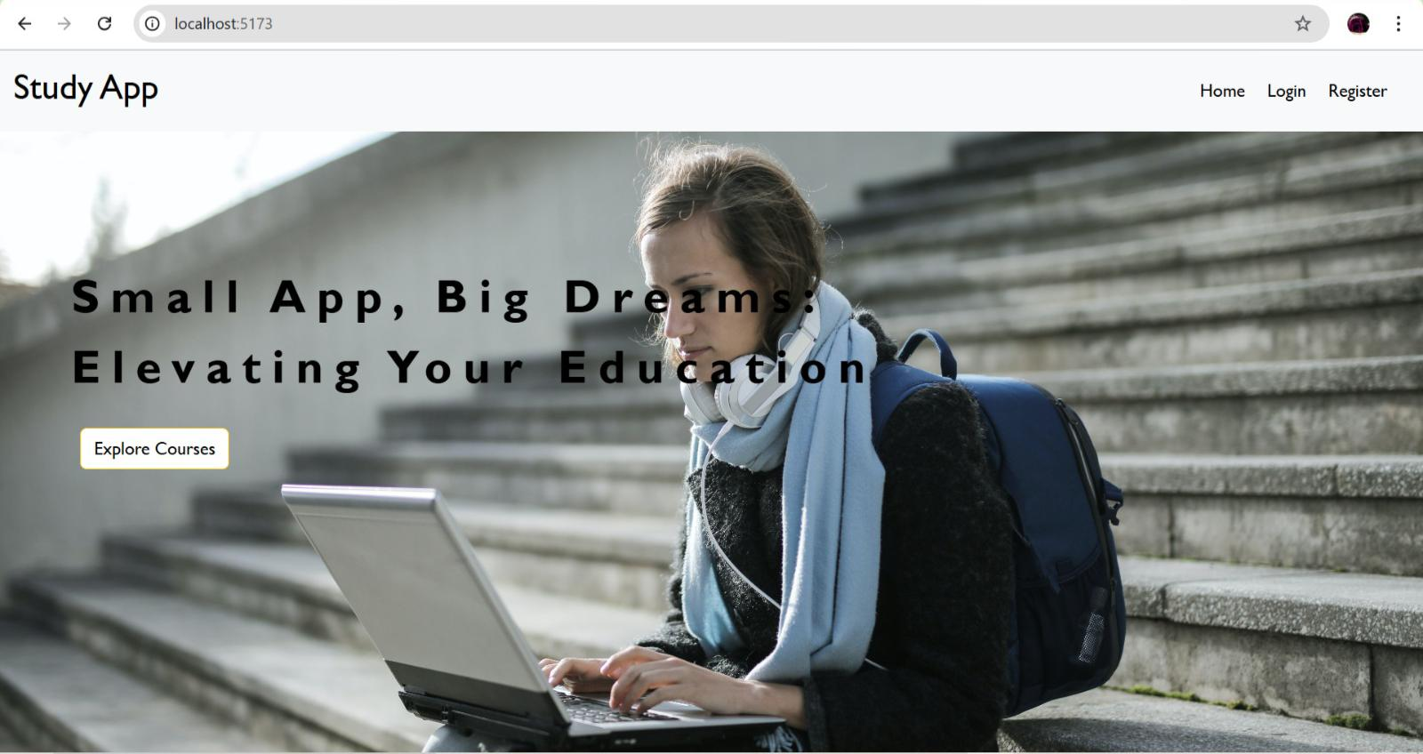

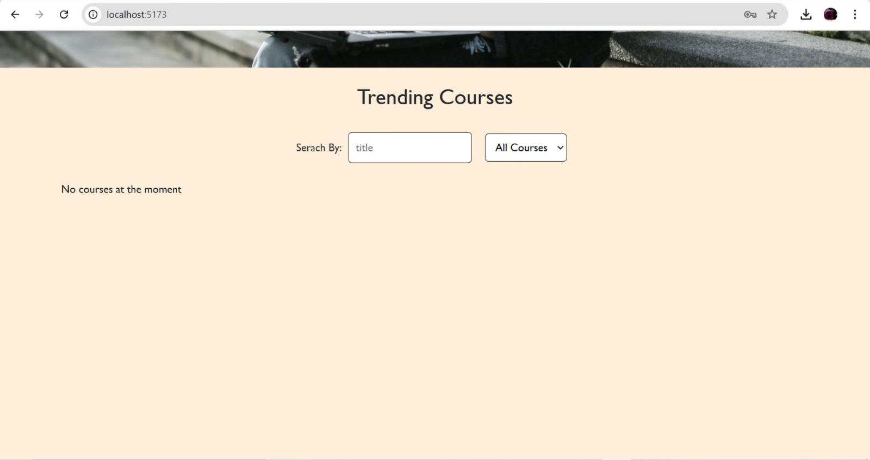

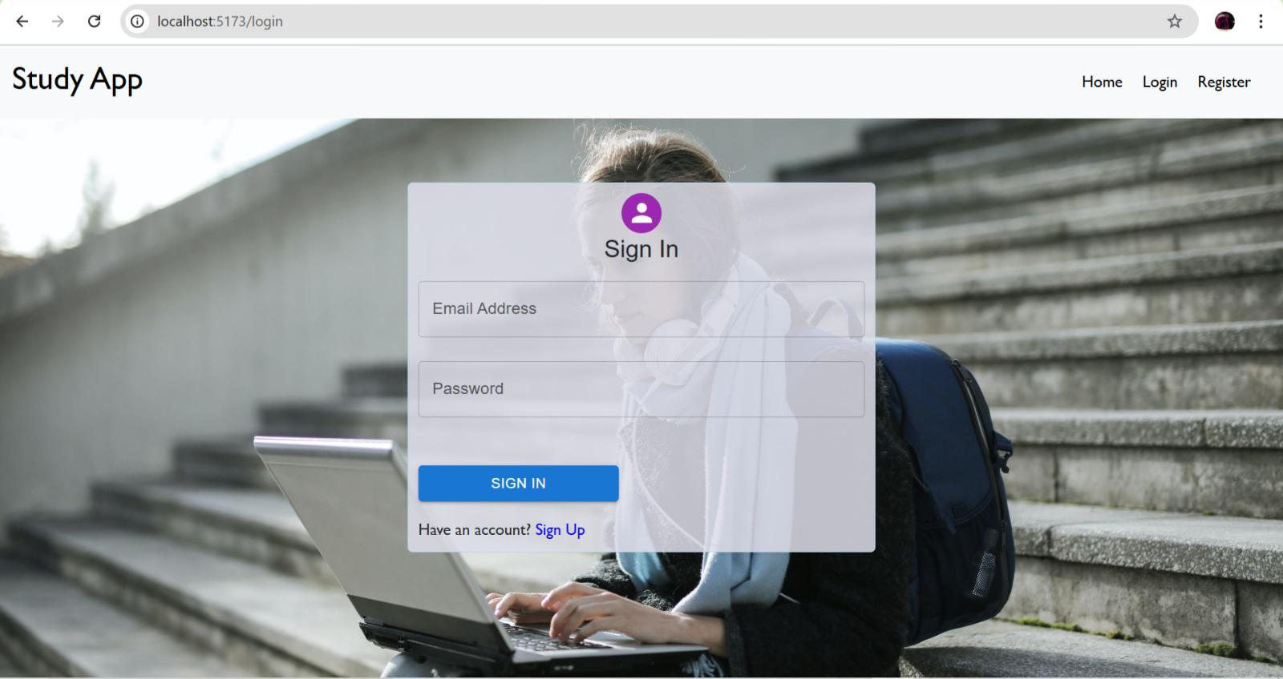**Sign in page:**

**Register page:**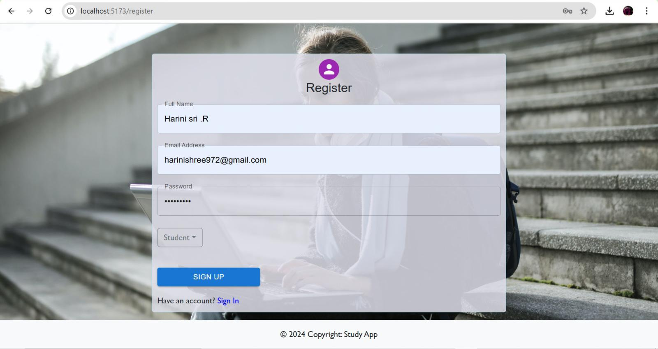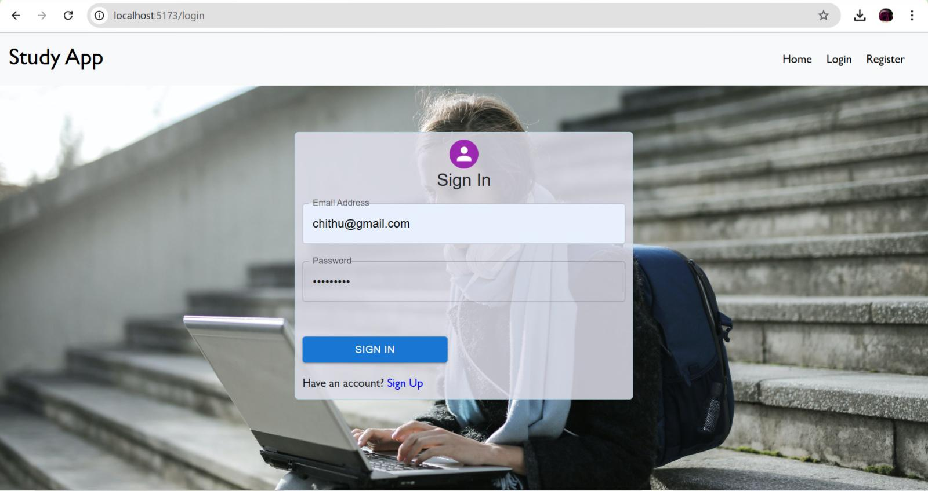

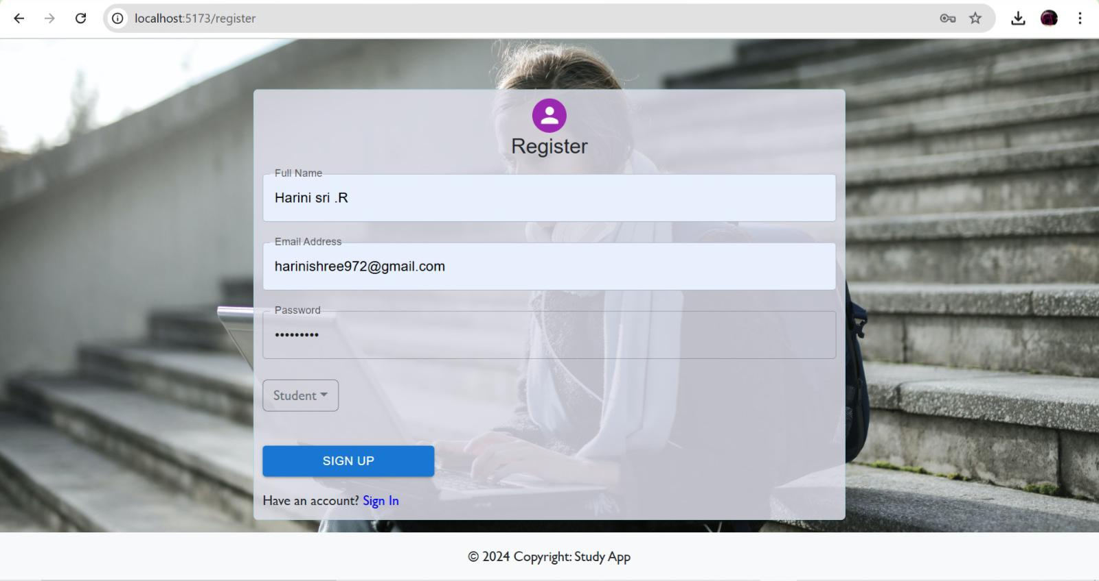

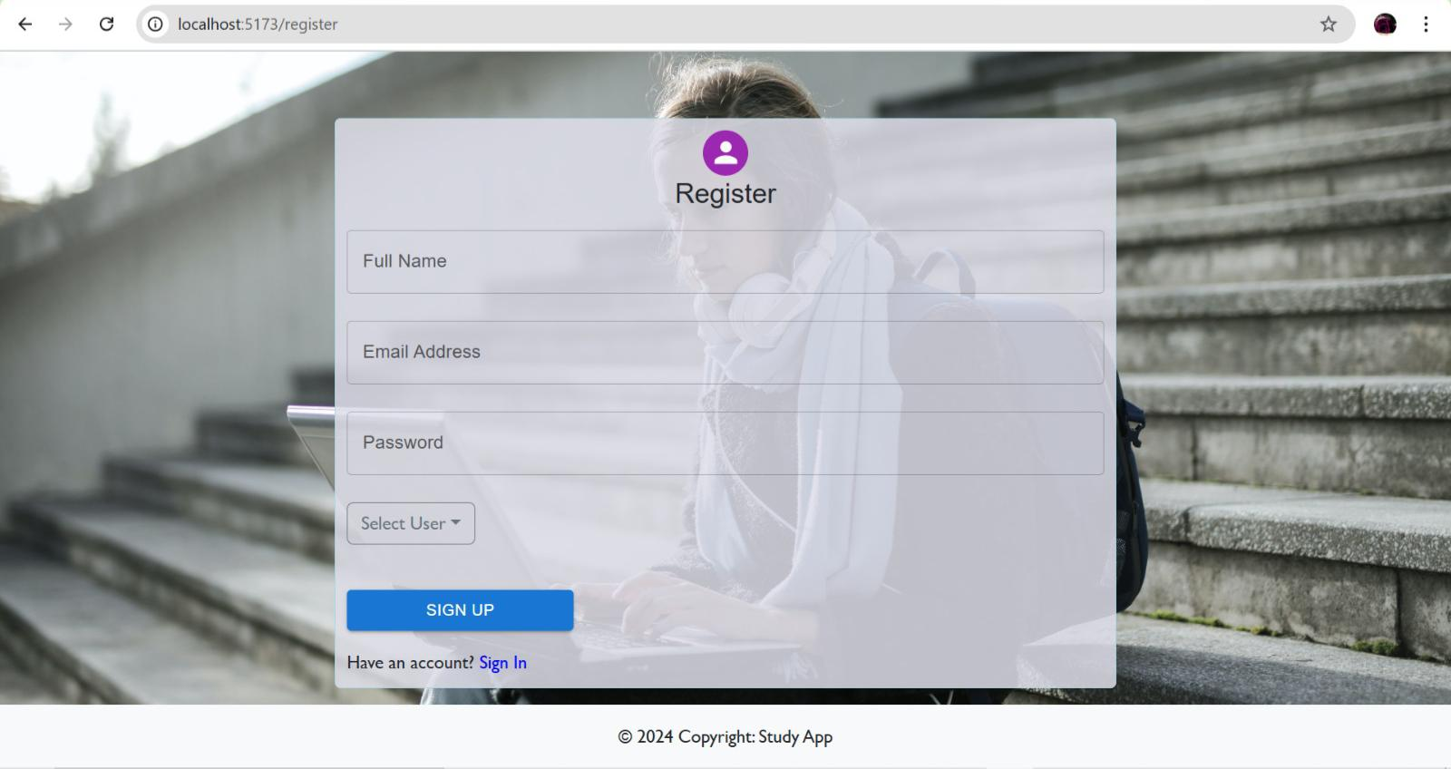

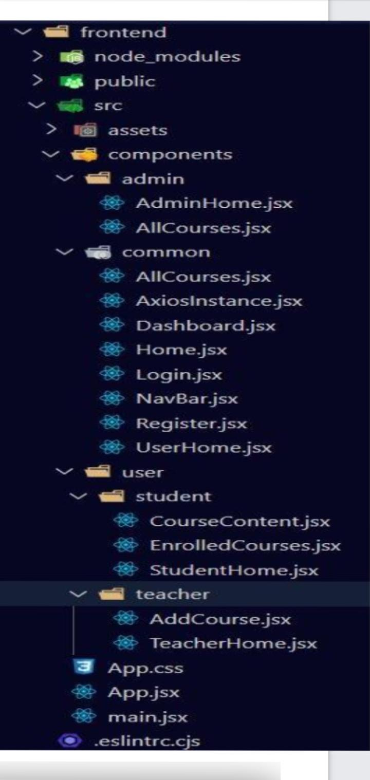

**7.future enchantments:**

The future of online learning platforms is full of potential advancements, aimed at creating more engaging, efficient, and personalized learning experiences. Here are several possible enhancements:

**Personalized Learning Pathways:**

AI-Driven Recommendations**:Machine learning algorithms can assess each learner's strengths, weaknesses, and preferences to create individualized learning plans.

Adaptive Content**: Content that adapts in real-time to the learner’s pace and comprehension level can help improve retention and engagement.

**Immersive Technologies**

- **Virtual Reality (VR) and Augmented Reality (AR)**: These can provide experiential learning in fields like medicine, engineering, and the arts, enabling virtual labs, field trips, and hands-on practice in a simulated environment.

- **Simulations and Gamification**: By making learning feel like a game or an adventure, platforms can improve engagement and deepen understanding through practice.

\***Enhanced Social Learning:**

- **Collaborative Tools**: Future platforms may incorporate real-time collaboration features such as group projects, brainstorming sessions, and virtual breakout rooms.

- **Peer Review and Community Learning**: More opportunities for peer assessments, group discussions, and mentorship can make learning more interactive and reflective.

**\*AI-Powered Tutors and Chatbots**

- **Virtual Tutors**: AI tutors can answer questions, provide hints, or explain complex concepts to assist learners outside of scheduled classes.

- **24/7 Support Chatbots**: Chatbots can offer instant feedback and answer general queries, making support readily available and keeping learners engaged.

\***Skill Assessments and Micro-Credentials**

Skill-Based Assessments**: Instead of just theoretical exams, future platforms may focus more on practical, real-world skill evaluations.

- **Micro-Credentialing and Certifications**: Short courses that lead to industry-recognized certifications or micro-credentials can validate specific skill sets and are increasingly valued by employers.

\***Real-Time Data Analytics and Feedback**

- **Progress Dashboards**: Personalized dashboards for both learners and instructors can track progress, strengths, and areas that need improvement.

- **Predictive Analytics**: Analytics could help predict a learner’s performance trajectory, alerting them to potential challenges and providing resources proactively.

**Lifelong Learning Ecosystems**

Cross-Platform Integration*: Online learning platforms could connect with other platforms, allowing learners to build portfolios of skills across different domains.

Continuous Learning Paths: Offering curated content based on career growth or personal interests can encourage a habit of lifelong learning.

**Accessibility and Inclusivity Enhancements**

- **Multilingual and Multimodal Content: Courses available in multiple languages, or with options for audio, text, or video, can cater to diverse learning needs.

- **Accessibility Features**: Integrating features like screen readers, captions, and transcripts to make courses accessible to people with disabilities.

.

\*\***Blockchain for Verification and Security**

- **Digital Credential: Blockchain could be used to verify and securely store certifications, ensuring authenticity and easing the sharing of credentials with employers.

*Secure Data Management**: Blockchain could also help improve the security of personal data on online platforms, ensuring that learners’ privacy is protected.

**Hybrid Learning Experiences:**

Blending Online with In-Person Components: Online learning platforms may offer ways to connect virtual and in-person activities, like internships or workshops, creating a more holistic learning experience.

Each of these enhancements can make online learning platforms more dynamic, responsive, and aligned with the needs of diverse learners and industries. As these technologies evolve, the focus will likely be on balancing automation with a human touch to foster deeper engagement and meaningful learning outcomes.